**Name:**

**Chapter 5 Programming Exercises (45 points)**

When developing your programs, please remember to add your header information. Use comments to self-document your code and be mindful of the spelling and formatting of your data, both *input* and *output*. Remember to validate your input.

Try to use each loop type when coding the following challenges:

**Exercise 1**

**Product of Numbers**

Write a program that asks the user for a positive integer value. The program should use a loop to get the product of all the integers from 1 up to the number 50. The loop will find the product of 1, 2, 3, 4, . . ., 50.

**Input Validation**: Do not accept a negative starting number or the number zero.

Output should be similar to the following:

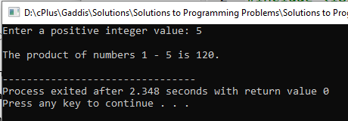

**Exercise 2**

**Distance Traveled**

The distance a vehicle travels can be calculated as follows:

distance = speed * time

For example, if a train travels 40 miles per hour for 3 hours, the distance traveled is 120 miles. Write a program that asks the user for the speed of a vehicle (in miles per hour) and how many hours it has traveled. The program should then use a loop to display the distance the vehicle has traveled for each hour of that time period.

Here is an example of the output:

What is the speed of the vehicle in mph? 40

How many hours has it traveled? 3 Hour

Distance Traveled --------------------------------

1 40

2 80

3 120

**Input Validation**: Do not accept a negative number for speed and do not accept any value less than 1 for time traveled.

An example of output is:

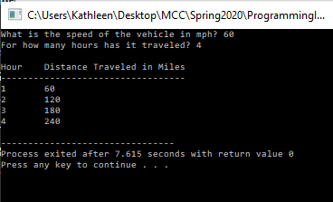

**Exercise 3**

**Calculate number of entries, max, min, sum, and average**

Write a program to ask a user to input a set of positive integers. Your program will calculate the number of entries, the maximum, the minimum, the sum, and the average. Terminate the loop with a -1. Display the average as a floating point number with no more than two decimal places.

